A
PROJECT REPORT
ON
LIBRARY MANAGEMENT SYSTEM

SUBMITTED FOR

A partial fulfilment of the requirement of
Central Board of Secondary Education, Delhi
for the academic year 2025-26



Coimbatore – 641 141

SUBMITTED TO: SUBMITTED BY:
MRS C JENETPRABA D KEVIN JONATHAN
TGT COMPUTER SCIENCE ROLL NO:

ACKNOWLEDGEMENT

First of all, I express a deep sense of gratitude to almighty God for giving me strength for the successful completion of the project. I express my sincere thanks to the Management and the Principal Mr. A BENJAMIN M.Sc. M.Ed. M.PHIL. MBA. for constant encouragement and the guidance provided during this project. I would like to express a deep sense of thanks and gratitude to my computer science teacher, Mrs. C. JENETPRABA MCA.,B.Ed. for guiding me immensely through the course of the project. She always evinced keen interest in my work. Her constructive advice and constant motivation have been responsible for the successful completion of this project. I also thank my parents and friends for their motivation and support towards the completion of this project. I am very thankful to CBSE for having given me this opportunity to understand the core programming principles and its applications in real world situations. Last but not least; I would like to thank all those who have supported me directly and indirectly in any manner for completion of this project.

Date: Name: D KEVIN JONATHAN

Signature of Candidate: Class: XII B

CERTIFICATE

This is to certify that the project work titled LIBRARY MANAGEMENT SYSTEM is developed by D. KEVIN JONATHAN, bearing a Roll number __________,
a student of Class XII. This project work is carried out to fulfill the partial requirement of Central Board of Secondary Education, Delhi for the academic year 2025-2026 for the subject Computer Science (083).

It is further certified that this project work is the individual and Bonafide work of the candidate.

SIGNATURE OF CANDIDATE SIGNATURE OF PRINCIPAL

INTERNAL EXAMINER EXTERNAL EXAMINER

INDEX
S. No. | TITLE | PAGE. NO.
01. | INTRODUCTION | 01
02. | OBJECTIVE OF THE PROJECT | 01
03. | PROPOSED SYSTEM | 01
04. | SOFTWARE DEVELOPMENT LIFE CYCLE | 01
05. | PHASES OF SOFTWARE DEVELOPMENT LIFE  CYCLE | 04
06. | HARDWARE AND SOFTWARE REQUIREMENTS | 08
07. | SOURCE CODE | 10
08. | OUTPUT | 15
09. | CONCLUSION | 28
10. | APPLICATION AND FUTURE SCOPE OF THE  PROJECT | 30
11. | BIBLIOGRAPHY | 34

INTRODUCTION:
Libraries can use this to upload and register new books coming into stock and update their old books, they can also use this program to check availability of books for loans and even register the loans taken by customers for the books. Such a facility reduces the time consumed in doing manual paperwork in obtaining and returning books taken from a library and makes the overall process faster and more convenient. This program could be done using several languages. Here we use Python and MySQL to handle this function.

OBJECTIVE OF THE PROJECT:
The purpose of this project is to create a portal-like environment in the python console that stores and show number of books present and loans that need to be taken care of. Admin can update the stock of books and loans and can view every process that’s done in the console. The objective of the project is to make it easier for librarians to upload and register loans and check their stock easily anywhere around the globe.

PROPOSED SYSTEM:
We have used python to provide the portal environment. Book’s name, ID, author and count should be entered in the python console to add new books, Loan’s ID, Book’s ID for the loan, Member’s ID and date of loan and return should be entered in the python console to add loans, for simplicity just the Loan’s ID is required for returning the loans. MySQL queries store every detail in a structured manner making it easy to access. When the table is created and data is input in python console by the Admin or Librarian, it gets stored or updated in MySQL since they are connected using MySQL connector function in python. The same tables are printed when the respective options are given by the user for displaying the book’s stock or loan table.

SOFTWARE DEVELOPMENT LIFE CYCLE:
Software Development Life Cycle (SDLC) is a process used by the software industry to design, develop and test high quality software. The SDLC aims to produce a high-quality software that meets or exceeds customer expectations, reaches completion within times and cost estimates.

- SDLC is the acronym of Software Development Life Cycle. It is also called as Software Development Process.
- *SDLC is a framework defining tasks performed at each step in the software development process.
- *ISO/IEC 12207 is an international standard for software life-cycle processes. It aims to be the standard that defines all the tasks required for developing and maintaining software.

What is SDLC?
SDLC is a process followed for a software project, within a software organization. It consists of a detailed plan describing how to develop, maintain, replace and alter or enhance specific software. The life cycle defines a methodology for improving the quality of software and the overall development process.

The following figure is a graphical representation of the various stages of a typical SDLC.

Stages of SDLC:
A typical Software Development Life Cycle consists of the following stages −

Stage 1: Planning and Requirement Analysis
Requirement analysis is the most important and fundamental stage in SDLC. It is performed by the senior members of the team with inputs from the customer, the sales department, market surveys and domain experts in the industry. This information is then used to plan the basic project approach and to conduct product feasibility study in the economical, operational and technical areas.

Planning for the quality assurance requirements and identification of the risks associated with the project is also done in the planning stage. The outcome of the technical feasibility study is to define the various technical approaches that can be followed to implement the project successfully with minimum risks.

Stage 2: Defining Requirements
Once the requirement analysis is done the next step is to clearly define and document the product requirements and get them approved from the customer or the market analysts. This is done through an SRS (Software Requirement Specification) document which consists of all the product requirements to be designed and developed during the project life cycle.

Stage 3: Designing the Product Architecture
SRS is the reference for product architects to come out with the best architecture for the product to be developed. Based on the requirements specified in SRS, usually more than one design approach for the product architecture is proposed and documented in a DDS - Design Document Specification.

This DDS is reviewed by all the important stakeholders and based on various parameters as risk assessment, product robustness, design modularity, budget and time constraints, the best design approach is selected for the product.
A design approach clearly defines all the architectural modules of the product along with its communication and data flow representation with the external and third party modules (if any). The internal design of all the modules of the proposed architecture should be clearly defined with the minutest of the details in DDS.

Stage 4: Building or Developing the Product
In this stage of SDLC the actual development starts and the product is built. The programming code is generated as per DDS during this stage. If the design is performed in a detailed and organized manner, code generation can be accomplished without much hassle
Developers must follow the coding guidelines defined by their organization and programming tools like compilers, interpreters, debuggers, etc. are used to generate the code. Different high level programming languages such as C, C++, Pascal, Java and PHP are used for coding. The programming language is chosen with respect to the type of software being developed.

Stage 5: Testing the Product
This stage is usually a subset of all the stages as in the modern SDLC models, the testing activities are mostly involved in all the stages of SDLC. However, this stage refers to the testing only stage of the product where product defects are reported, tracked, fixed and retested, until the product reaches the quality standards defined in the SRS.

Stage 6: Deployment in the Market and Maintenance
Once the product is tested and ready to be deployed it is released formally in the appropriate market. Sometimes product deployment happens in stages as per the business strategy of that organization. The product may first be released in a limited segment and tested in the real business environment (UAT- User acceptance testing).

Then based on the feedback, the product may be released as it is or with suggested enhancements in the targeting market segment. After the product is released in the market, its maintenance is done for the existing customer base

PHASES OF SOFTWARE DEVELOPMENT LIFE CYCLE:
7 Stages of the System Development Life Cycle

There are seven primary stages of the modern system development life cycle. Here’s a brief breakdown:

- Planning Stage
- Feasibility or Requirements of Analysis Stage
- Design and Prototyping Stage
- Software Development Stage
- Software Testing Stage
- Implementation and Integration
- Operations and Maintenance Stage

Planning Stage:
Before we even begin with the planning stage, the best tip we can give you is to take time and acquire proper understanding of app development life cycle.

The planning stage (also called the feasibility stage) is exactly what it sounds like:
The phase in which developers will plan for the upcoming project.

It helps to define the problem and scope of any existing systems, as well as determine the objectives for their new systems.

By developing an effective outline for the upcoming development cycle, they'll theoretically catch problems before they affect development.
And help to secure the funding and resources they need to make their plan happen.

Perhaps most importantly, the planning stage sets the project schedule, which can

Be of key importance if development is for a commercial product that must be sent to market by a certain time.

Analysis Stage:

The analysis stage includes gathering all the specific details required for a new system as well as determining the first ideas for prototypes.

Developers may:

*Define any prototype system requirements.
*Evaluate alternatives to existing prototypes.
*Perform research and analysis to determine the needs of end-users.

Furthermore, developers will often create a software requirement specification or SRS document.

This includes all the specifications for software, hardware, and network requirements for the system they plan to build. This will prevent them from overdrawing funding or resources when working at the same place as other development teams.

Design Stage:
The design stage is a necessary precursor to the main developer stage.
Developers will first outline the details for the overall application, alongside specific aspects, such as its:

- User interfaces
- System interfaces
- Network and network requirements
- Databases

They’ll typically turn the SRS document they created into a more logical structure that can later be implemented in a programming language. Operation, training, and maintenance plans will all be drawn up so that developers know what they need to do throughout every stage of the cycle moving forward.
Once complete, development managers will prepare a design document to be referenced throughout the next phases of the SDLC.

Development Stage:
The development stage is the part where developers actually write code and build the application according to the earlier design documents and outlined specifications.
This is where Static Application Security Testing or SAST tools come into play. Product program code is built per the design document specifications. In theory, all of the prior planning and outlined should make the actual development phase relatively straightforward.
Developers will follow any coding guidelines as defined by the organization and utilize different tools such as compilers, debuggers, and interpreters.
Programming languages can include staples such as C++, PHP, and more. Developers will choose the right programming code to use based on the project specifications and requirements.

Testing Stage:

Building software is not the end.
Now it must be tested to make sure that there aren’t any bugs and that the end- user experience will not negatively be affected at any point.
During the testing stage, developers will go over their software with a fine-tooth comb, noting any bugs or defects that need to be tracked, fixed, and later retested. It’s important that the software overall ends up meeting the quality standards that were previously defined in the SRS document.
Depending on the skill of the developers, the complexity of the software, and the requirements for the end-user, testing can either be an extremely short phase .

Implementation and Integration Stage:
After testing, the overall design for the software will come together. Different modules or designs will be integrated into the primary source code through developer efforts, usually by leveraging training environments to detect further errors or defects.
The information system will be integrated into its environment and eventually installed. After passing this stage, the software is theoretically ready for market and May be provided to any end-users.

Maintenance Stage:
The SDLC doesn’t end when software reaches the market. Developers must now move into a maintenance mode and begin practicing any activities required to handle issues reported by end-users

Furthermore, developers are responsible for implementing any changes that the software might need after deployment.
This can include handling residual bugs that were not able to be patched before launch or resolving new issues that crop up due to user reports. Larger systems may require longer maintenance stages compared to smaller systems.

What is Python?
Python is a popular programming language.
It was created by Guido van Rossum, and released in 1991. It is used for:
- Web-Development(server-side)
- Software-Development
- Mathematics
- System scripting

Python:
Python is an interpreted, high-level and general-purpose programming language. Python works on different platforms (Windows, Mac, Linux, Raspberry Pi, etc). Python has a simple syntax similar to the English language.
Python has syntax that allows developers to write programs with fewer lines than some other programming languages.
Python runs an interpreting system, meaning that code can be executed as soon as it is written.
This means Python runs on an interpreter that prototyping can be very quick. Python can be treated in a procedural way, an object-oriented way or a functional way.
Python is a high-level language. When we write programs in python, we do not need to remember the system architecture, nor do we need to manage the memory.
Python is a high-level programming language. Python is very easy to learn the language as compared to other languages like C, Java script, Java, etc.
It is very easy to code in python language and anybody can learn python basics in a few hours or days. It is also a developer-friendly language.

SOFTWARE AND HARDWARE REQUIREMENTS

- OPERATINGSYSTEM : WINDOWS 10 ANDABOVE

- PROCESSOR : PENTIUM(ANY) OR AMD ATHALON(3800+-
          - 4200+ DUALCORE)

- MOTHERBOARD : 1.845 OR 915,995 FOR PENTIUM(ANY)
          - OR MSI K9MM-V VIAK8M800+8237RPLUS CHIPSETFOR AND ATHALON512MB+

- RAM :512MB+

- Hard Disk : SATA 40 GB ORABOVE

- CD/DVD r/w multi-drive : (If Backup is required) Combo

- FLOPPYDRIVE1.44MB : (If Backup is required) VIII.MONITOR 14.1 OR 15-17Inch

- Keyboard and Mouse

- Printer : (if printer is required-[Hardcopy])

SOFTWARE REQUIREMENTS

- WINDOWSOS

- Python

SOURCE CODE
SOURCE CODE

main.py

from book_module import add_book, view_books, search_book
from loan_module import issue_loan, return_loan, view_loans
from library_report_module import library_stats

def main_menu():
while True:
print("\n=== LIBRARY MANAGEMENT SYSTEM ===")
print("1. View Books")
print("2. Add Book")
print("3. Search Book")
print("4. View Loans")
print("5. Issue Loan")
print("6. Return Loan")
print("7. Library Report")
print("8. Exit")
choice = input("Enter your choice (1-8): ")
if choice == "1":
view_books()
elif choice == "2":
add_book()
elif choice == "3":
search_book()
elif choice == "4":
view_loans()
elif choice == "5":
issue_loan()
elif choice == "6":
return_loan()
elif choice == "7":
library_stats()
elif choice == "8":
print("Successfully Exitted...")
break
else:
print("Invalid choice. Try again.")
task = input("\nDo you wish to continue(y/n): ")
if task.lower() == 'n':
print("Successfully Exitted...")

Break

a = "admin"
b = 1234
user = input("Enter username: ")
passcode = eval(input("Enter password: "))

if user == a and passcode == b:
main_menu()

connector.py

import mysql.connector as mc

def connection():
return mc.connect( host="localhost",user="root",
password="KCS@TIGER",
database="CSProject" )

book_module.py

from connector import connection

def add_book():
book_id = input("Enter Book ID: ")
name = input("Enter Book Name: ")
author = input("Enter Author Name: ")
copies = int(input("Enter Total Copies: "))
con = connection()
cur = con.cursor()
cur.execute("insert into Books values (%s,%s,%s,%s)", (book_id, name, author, copies))
con.commit()
con.close()
print("Book added successfully!\n")

def view_books():
con = connection()
cur = con.cursor()
cur.execute("select * from Books")
data = cur.fetchall()
con.close()
print("\n=== BOOK LIST ===")
for row in data:
print(row)
print()

def search_book():
name = input("Enter Book Name to search: ")
con = connection()
cur = con.cursor()
cur.execute("select * from Books where BookName like %s", ['%'+name+'%'])
results = cur.fetchall()
con.close()
if results:
print("\nResults:")

for row in results:
print(row)
else:
print("No matching books found.")
print()

loan_module.py

from connector import connection

def issue_loan():
loan_id = input("Enter Loan ID: ")
book_id = input("Enter Book ID: ")
member_id = input("Enter Member ID: ")
loan_date = input("Enter Loan Date (YYYY-MM-DD): ")
due_date = input("Enter Due Date (YYYY-MM-DD): ")
con = connection()
cur = con.cursor()
cur.execute("select TotalCopies from Books where BookID= %s", (book_id,))
copies = cur.fetchone()
if not copies:
print("Book ID not found.\n")
con.close()
return
if copies[0] <= 0:
print("No copies available.\n")
con.close()
return
cur.execute("insert into BookLoan values (%s,%s,%s,%s,%s)", (loan_id, book_id, member_id, loan_date, due_date))
cur.execute("update Books set TotalCopies = TotalCopies - 1 where BookID=%s", (book_id,))
con.commit()
con.close()
print("Loan issued successfully!\n")

def return_loan():
loan_id = input("Enter Loan ID to return: ")
con = connection()
cur = con.cursor()
cur.execute("select BookID from BookLoan where LoanID=%s", (loan_id,))
book = cur.fetchone()
if not book:
print("Loan ID not found.\n")
con.close()
return
cur.execute("delete from BookLoan where LoanID=%s", (loan_id,))

cur.execute("update Books set TotalCopies = TotalCopies + 1 where BookID=%s", (book[0],))
con.commit()
con.close()
print("Book returned successfully!\n")

def view_loans():
con = connection()
cur = con.cursor()
cur.execute("select * from BookLoan")
loans = cur.fetchall()
con.close()
print("\n=== CURRENT LOANS ===")
for row in loans:
print(row)
print()

library_report_module.py

from connector import connection

def library_stats():
con = connection()
cur = con.cursor()

cur.execute("select count(*) from Books")
total_books = cur.fetchall()[0][0]

cur.execute("select count(*) from BookLoan")
total_loans = cur.fetchall()[0][0]

cur.execute("select sum(TotalCopies) from Books")
available_copies = cur.fetchall()[0][0]

con.close()

print("\n=== LIBRARY REPORT ===")
print("Total Books: ", total_books)
print("Total Loans: ", total_loans)
print("Available Copies: ", available_copies)

OUTPUT

Data From MySQL:

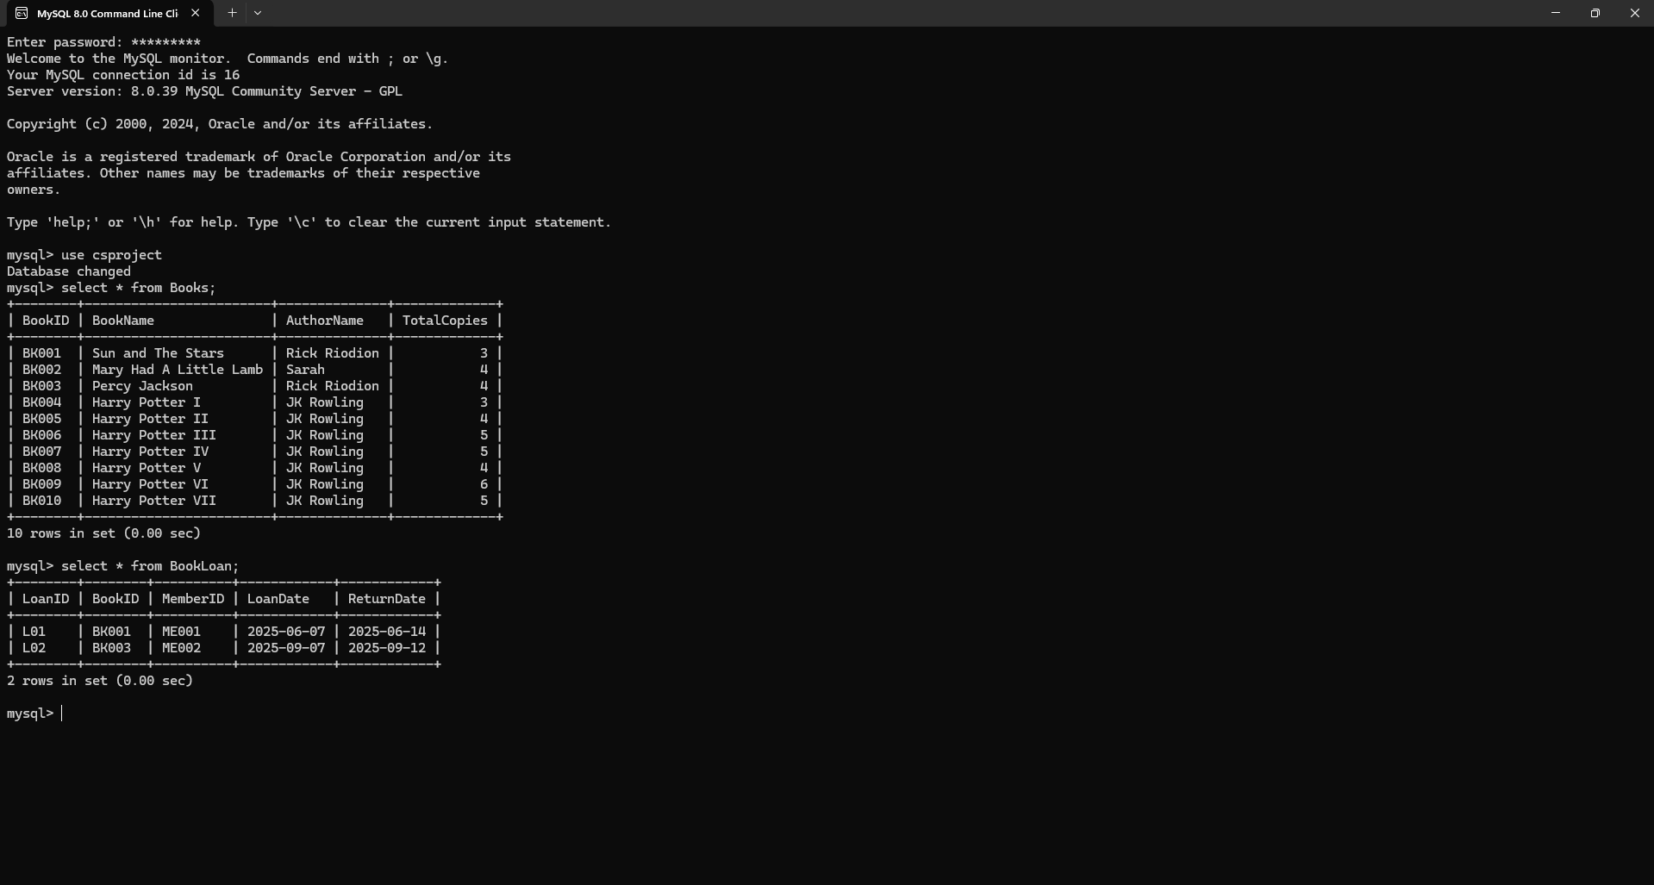

Opening Menu:

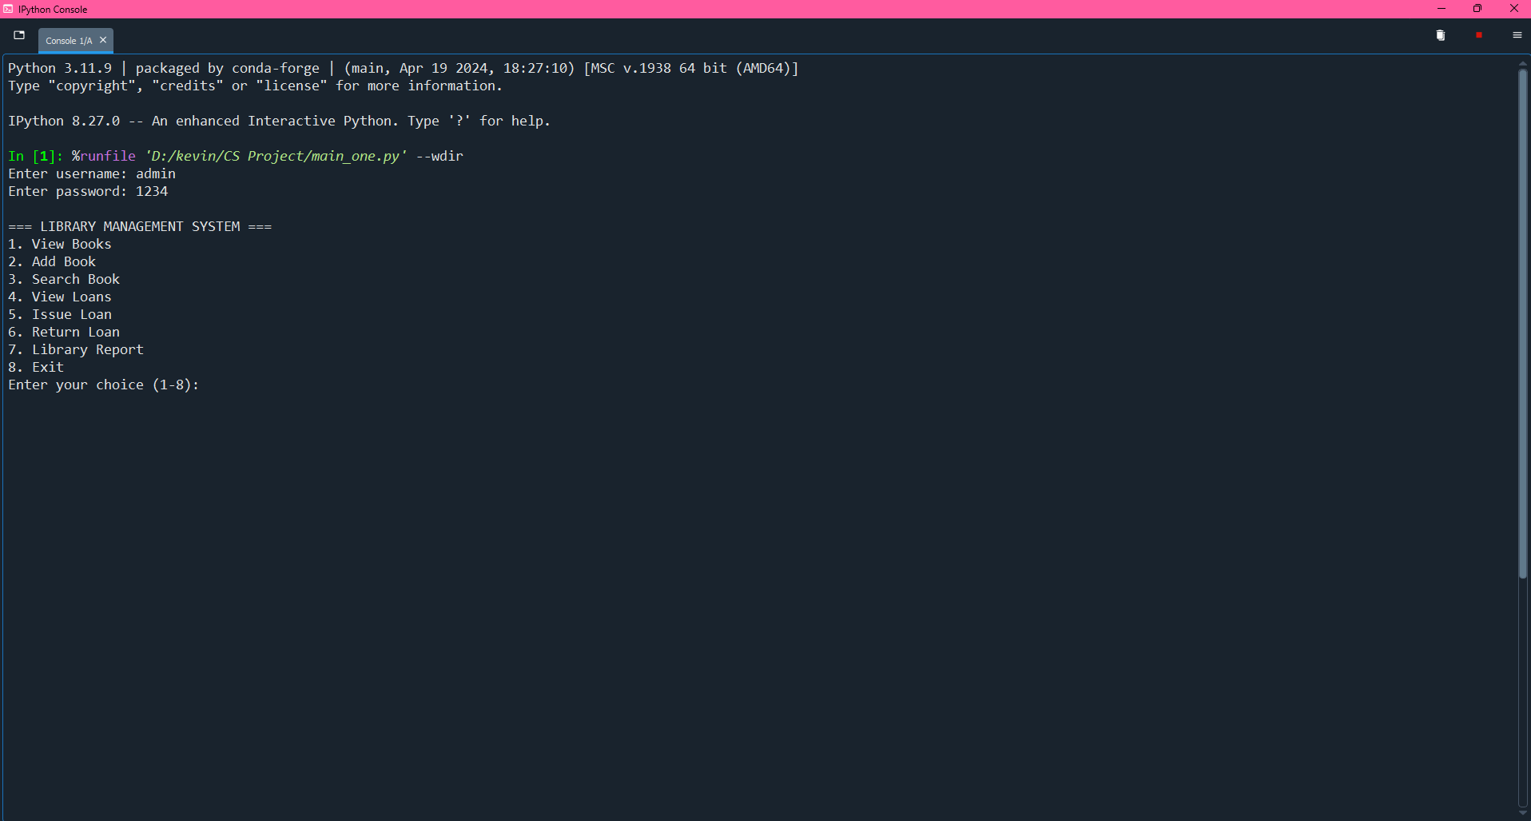

Viewing The Books Table:

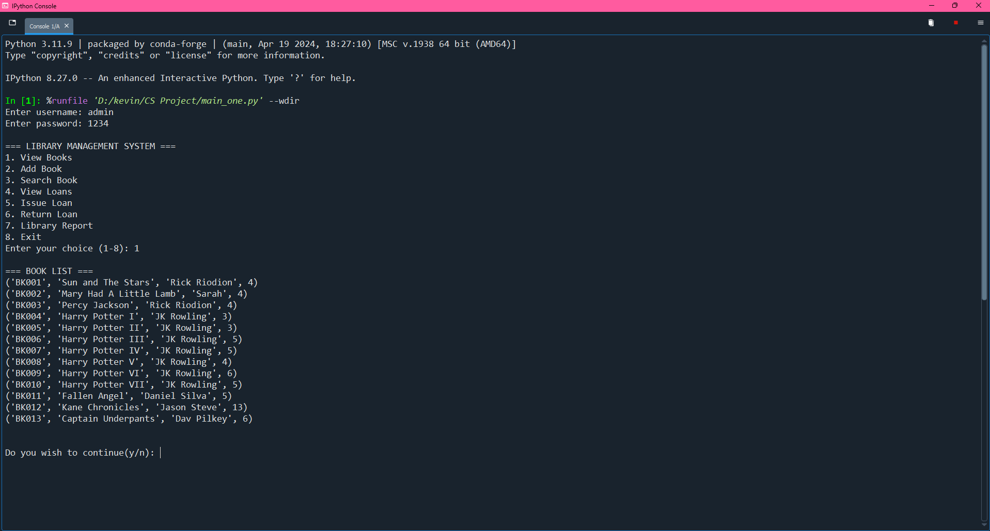

Adding Books:

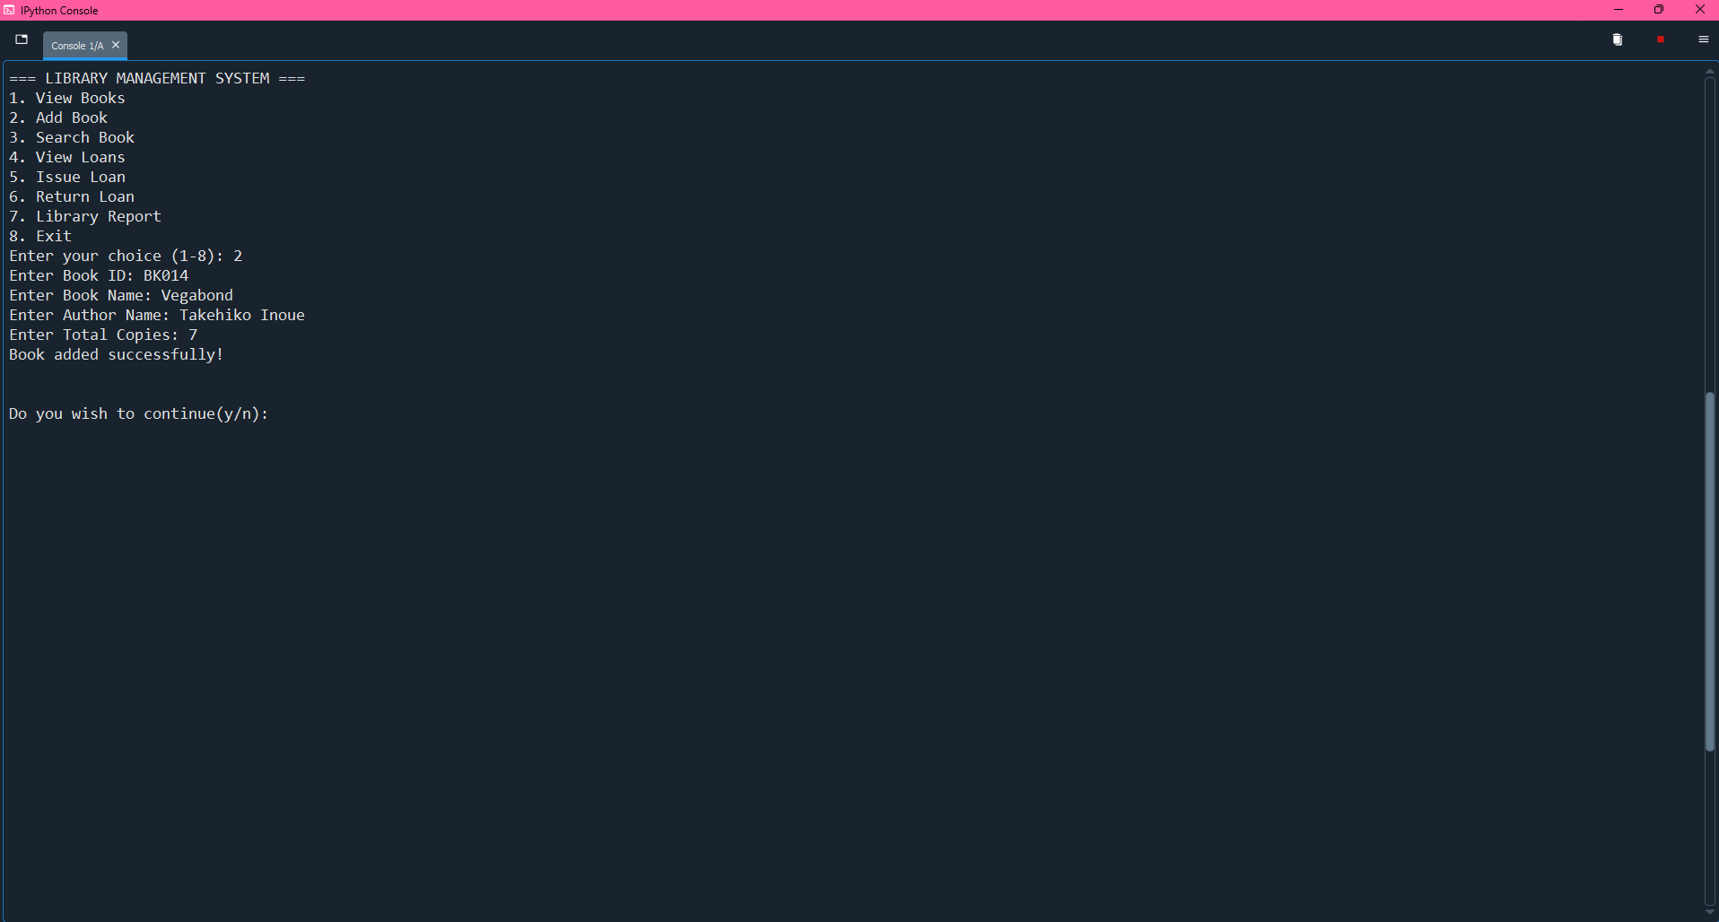

Searching Books:

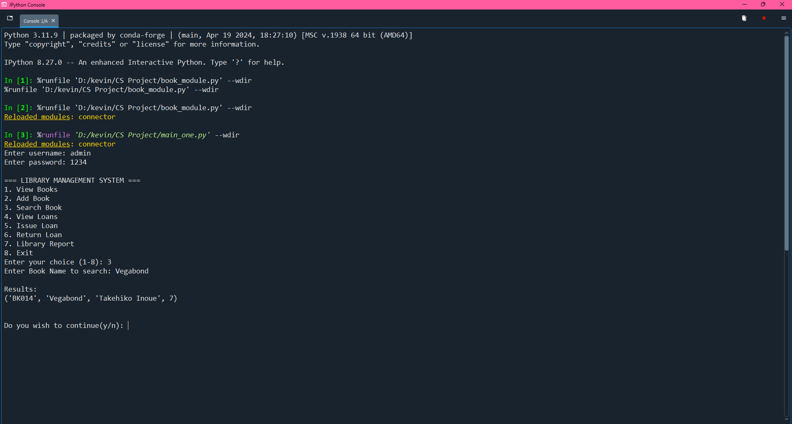

Viewing The Loans Table:

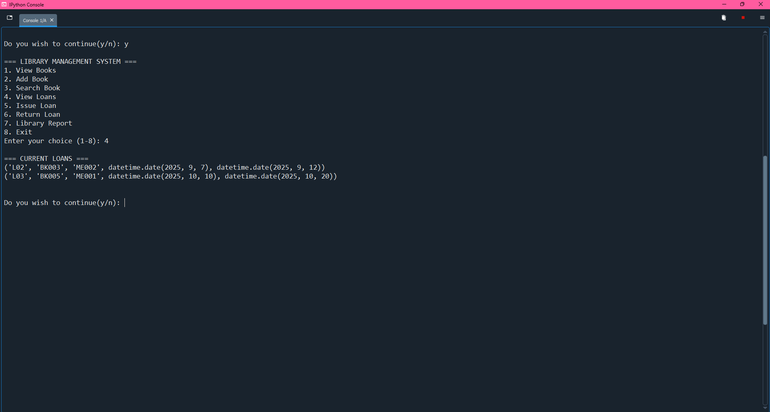

Adding A Loan:

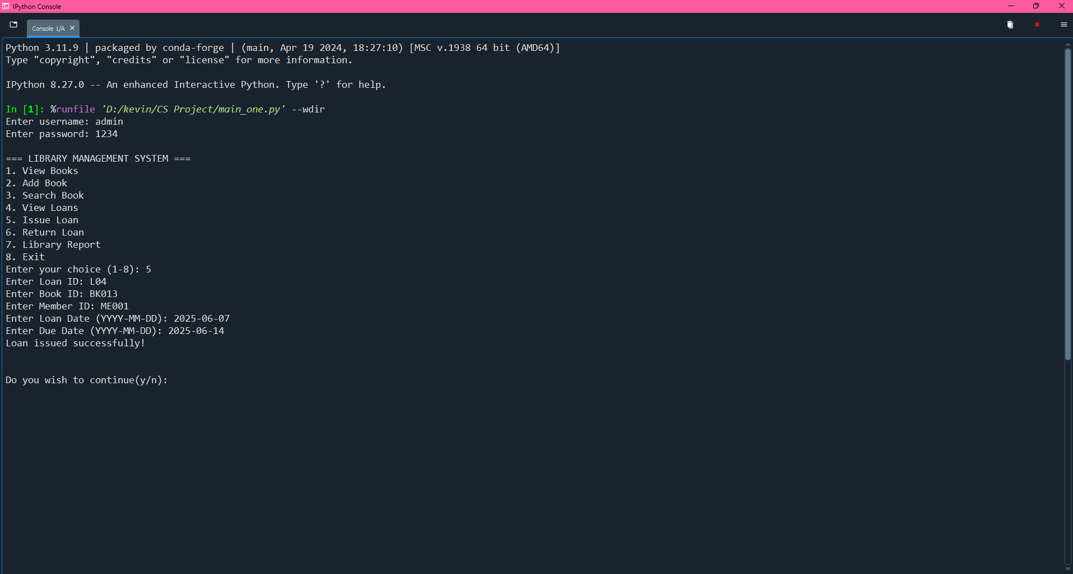

Returning A Loan:

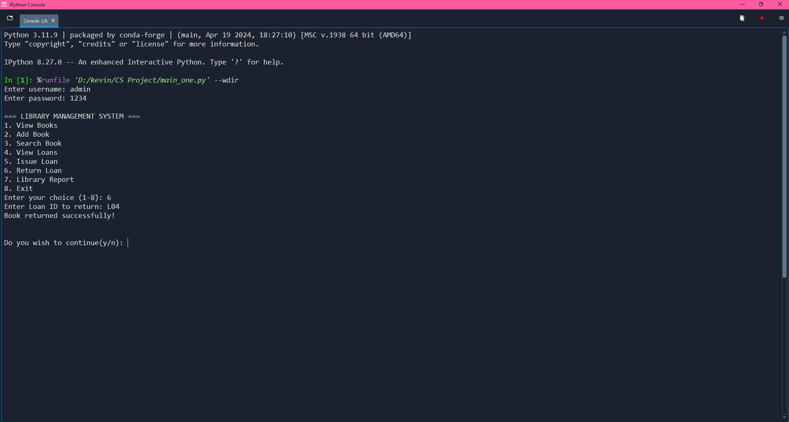

Book and Loan Tables After Returning The Loan:

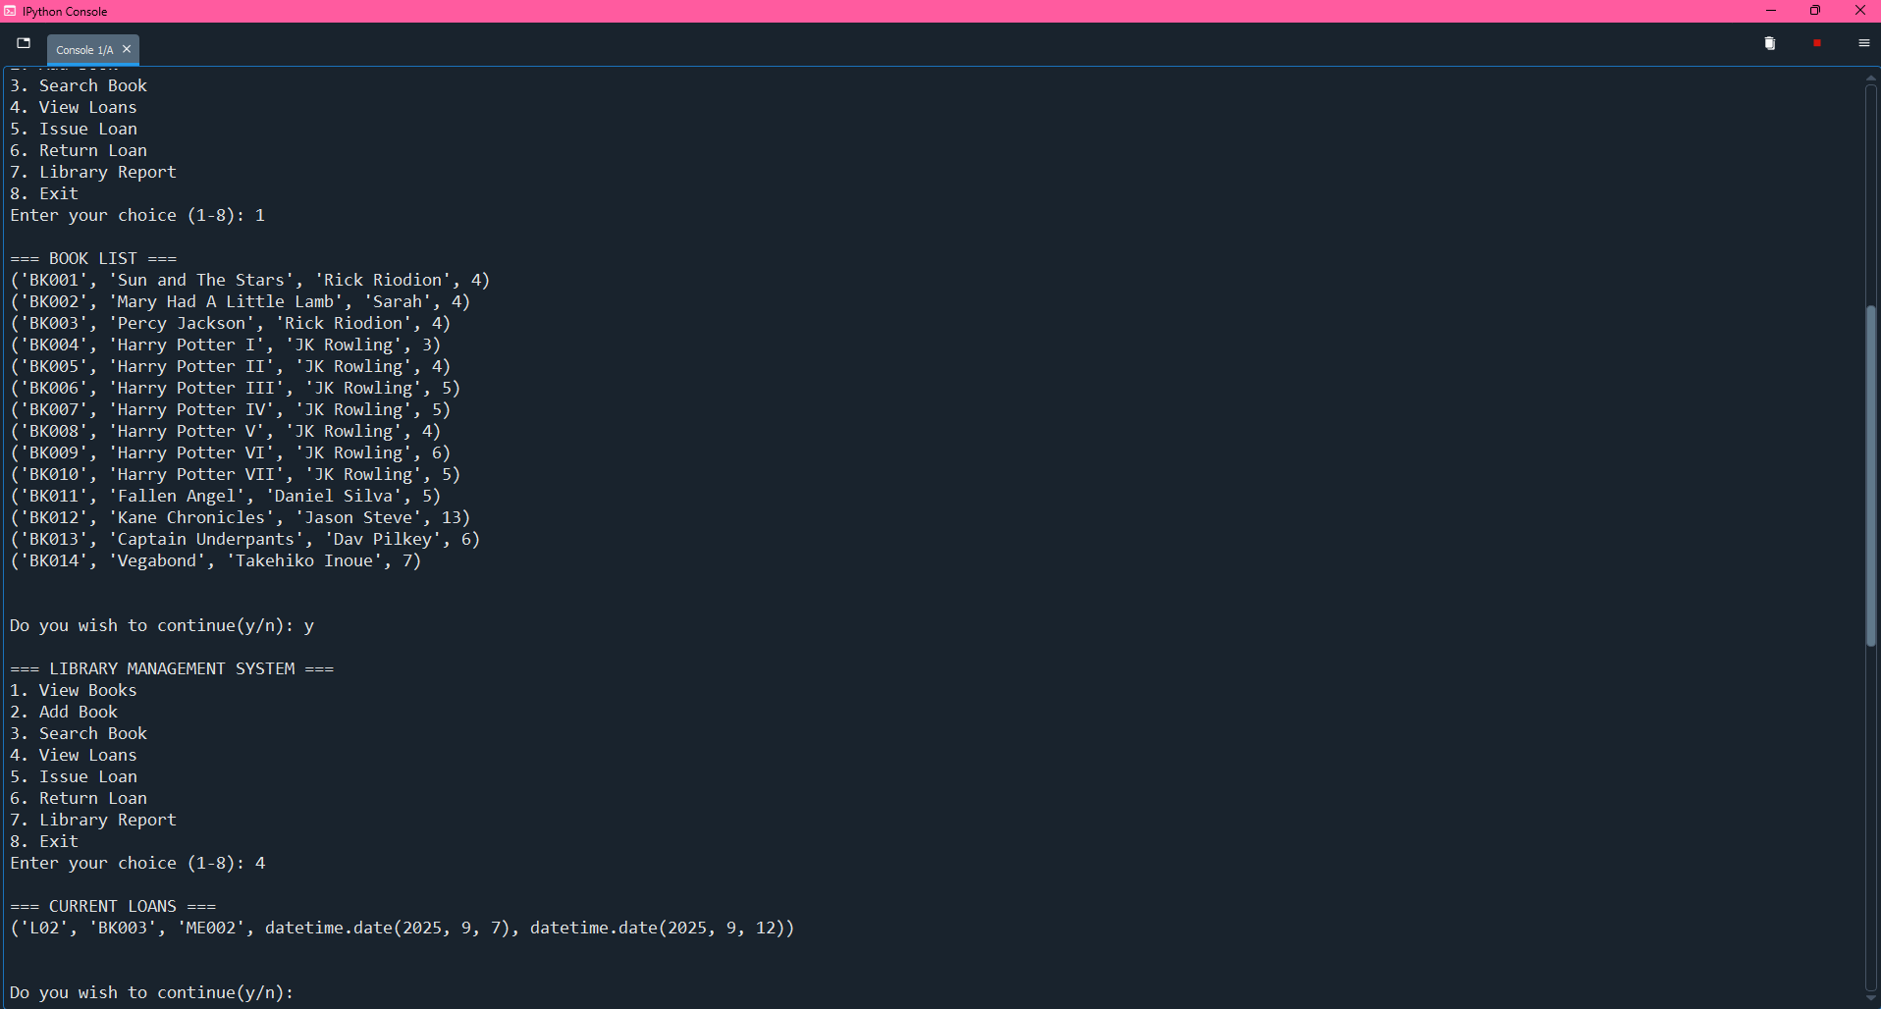

Changes Applied in the MySQL Table:

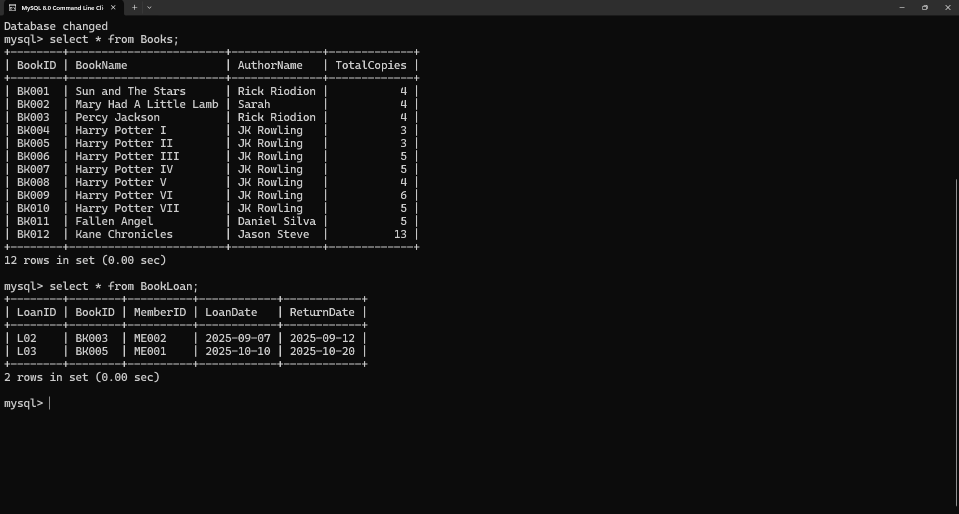

CONCLUSION

This coursework has helped us to explore more in python programming language. We learnt that python programming is a great degree valuable apparatuses to manufacture and create many projects and programming. The stock administration framework is valuable as it keeps the record of the item in the different type of stores and in addition it causes client to screen their buy.

Similarly, it has helped us to achieve the new level of the imagination and have given us the certainty to grow more projects and to improve our programming abilities and skills as well as to improve our programming understanding level. After the consummation of the coursework it was important to guarantee that it was bug and mistake free, such a significant number of test were done which affirmed that the projects were prepared to use in the genuine situation and can be refreshed if necessary in future
.
From the overall coursework, it gives us a knowledge about not only python programming language.

Hence indisputably, the coursework has been an amazing help to learn and get the more information about the python programming language. Moreover, it has helped us in additionally creating distinctive different ability and educated numerous things which will help in our profession life in future. This undertaking has still got spaces for the change. At long last, we foresee accomplishing more undertakings in coming future.

APPLICATION AND FUTURE
SCOPE OF THE PROJECT

Future Scope:

The current system is console-based, but it can be upgraded to a web-based or cloud-based application. Students, teachers, and librarians can access the library from anywhere at any time. This will make the system more flexible and reduce dependency on the physical presence of a librarian. Municipal or community libraries can use this system to manage a large collection of books efficiently. The system can be integrated with online book platforms to provide recommendations, reviews, and book requests.
This enhances the usability and engagement of the system among students and readers.

Although the code isn’t perfect, anything is possible with minor tweaking and some bug fixing thus enhancing the user experience.

Application of the Project:

The Library Management System is a versatile project that can be expanded and adapted in multiple ways. From simple console-based management to advanced cloud and mobile integration, its future scope is enormous. Its applications are widespread, ranging from educational institutions to corporate resource centers and community libraries. By implementing future enhancements such as digital access, notifications, analytics, and security features, the system can become a fully functional and modern library management solution.

BIBLIOGRAPHY

Websites:

1. https://www.guru99.com/software-testing-life-cycle.html
2. https://www.tutorialspoint.com/sdlc/sdlc_overview.htm
3. https://stackoverflow.com/questions/31892673/creating-sql-table-with-variable-name- from-python
4. https://www.geeksforgeeks.org/software-testing-life-cycle-stlc/
5. https://www.clouddefense.ai/blog/system-development-life-cycle

Books:

- Class XII Computer Science with Python - Sumita
- Class XII Textbook for Computer Science – NCERT
- Let Us Python - Yashavant Kanetkar

THANK YOU

